
AI/ML INTERNSHIP
Srishti Innovative

Akshaya anil
sh college

MACHINE LEARNING
Machine Learning (ML) is a part of AI where computers learn patterns from data instead of being explicitly programmed. In normal programming, you give rules to the computer and it generates result based on them. But in machine learning, you feed the computer data and make it study and then the computer generates results based on the studied data.
Example:
- Spam detection
- Netflix recommendations
- Face recognition
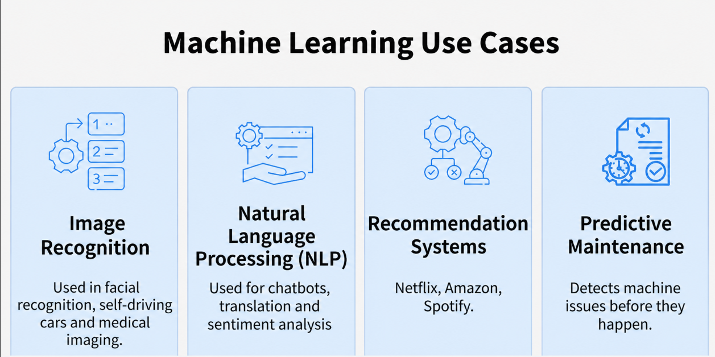
TYPES OF MACHINE LEARNING:
- Supervised Learning: Trains models on labelled data to predict or classify new, unseen data. Input and correct output is given to the computer.
- Unsupervised Learning: Finds patterns or groups in unlabelled data, like clustering or dimensionality reduction. Model tries to find patterns on its own.
- Reinforcement Learning: Learns through trial and error to maximize rewards, ideal for decision-making tasks.
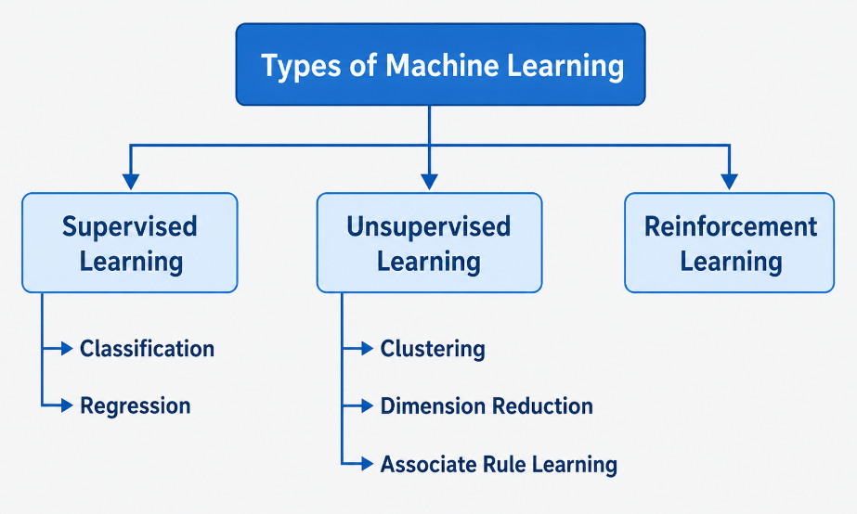

- Supervised Learning
Supervised Learning is defined as when a model gets trained on a "Labelled Dataset". Labelled datasets have both input and output parameters. In Supervised Learning algorithms learn to map points between inputs and correct outputs. 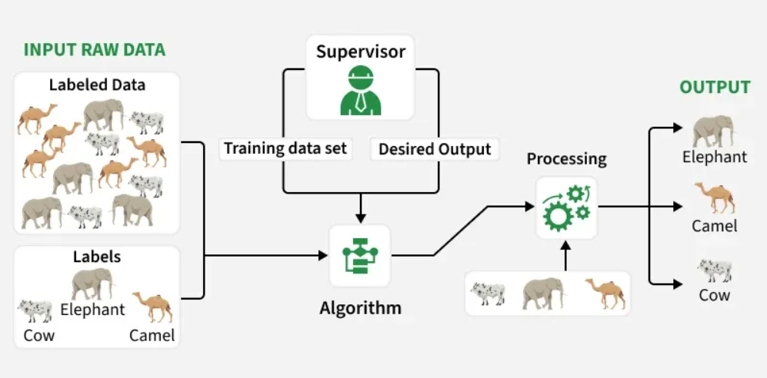
Example: If you train a model using labelled images of cats and dogs, it learns the features of each. When shown a new image, it predicts whether it’s a cat or a dog.
There are two main categories of supervised learning that are mentioned below:
1. Classification:
Classification predicts categorical outputs, meaning it assigns data into predefined classes like spam/non-spam emails or disease risk categories. These algorithms learn to map input features to discrete labels.
Example algorithms: Logical Regression, Decision Tree, K-Nearest Neighbour
2. Regression:
Regression predicts continuous values, such as house prices or product sales. It learns the relationship between input features and a numerical target variable.
Example algorithms: Linear Regression, Polynomial Regression, Lasso Regression
Where to Use Supervised Learning
- When you have labelled data and want to predict outcomes.
- Ideal for classification (like spam detection) or regression tasks (like price forecasting).
- Best used in domains where historical data with outcomes is already available.
Applications
Image, speech and text processing, predictive analysis, recommendation, automation
- Unsupervised Learning
Unsupervised Learning is a type of machine learning where the model works without labelled data. It learns patterns on its own by grouping similar data points or finding hidden structures without any human intervention.
- It is used for tasks like clustering, dimensionality reduction.
- Helps identify hidden patterns in data
- Useful for grouping, compression and anomaly detection
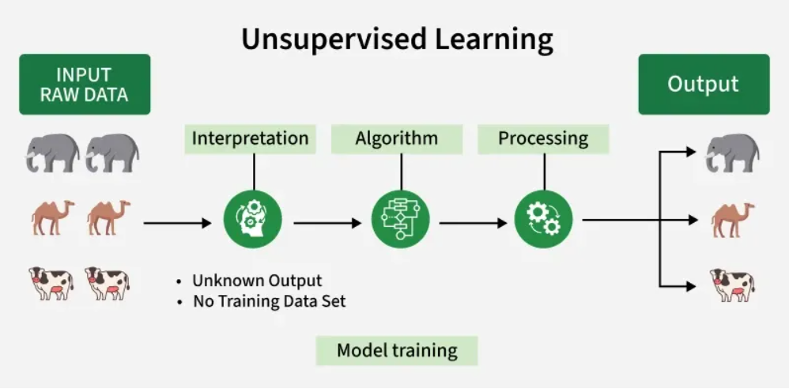
The image shows set of animals like elephants, camels and cows that represents raw data that the unsupervised learning algorithm will process.
- The "Interpretation" stage signifies that the algorithm doesn't have predefined labels or categories for the data. It groups the data based on inherent patterns.
- An algorithm represents unsupervised learning process that helps to identify patterns in the data.
- The processing stage shows the algorithm working on the data.
WORKING:
1. Collect Unlabelled Data
- Gather a dataset without predefined labels or categories.
- Example: Images of various animals without any tags.
2. Select an Algorithm
- Choose a suitable unsupervised algorithm such as clustering like K-Means, association rule learning like Apriori or dimensionality reduction like PCA based on the goal.
3. Train the Model on Raw Data
- Feed the entire unlabeled dataset to the algorithm.
- The algorithm looks for similarities, relationships or hidden structures within the data.
4. Group or Transform Data
- The algorithm organizes data into groups (clusters), rules or lower-dimensional forms without human input.
- Example: It may group similar animals together or extract key patterns from large datasets.
5. Interpret and Use Results
- Analyze the discovered groups, rules or features to gain insights or use them for further tasks like visualization, anomaly detection or as input for other models.
Advantages:
- Works with raw, unlabeled data, saving time and effort required for data annotation.
- Finds hidden patterns and natural groupings in data that may not be easily identified by humans.
- Handles large and complex datasets efficiently, including high-dimensional data.
- Helps detect anomalies and unusual data points without needing prior examples.
Challenges:
- Noisy data and outliers can distort patterns and reduce the effectiveness of the model.
- Models may capture noise instead of meaningful patterns, leading to overfitting.
- Lack of labeled data makes it difficult to guide the algorithm toward specific outcomes.
- Results such as clusters may be difficult to interpret or may not clearly match real-world categories.

- Reinforcement Learning
Reinforcement Learning (RL) is a branch of machine learning that focuses on how agents can learn to make decisions through trial and error to maximize cumulative rewards. RL allows machines to learn by interacting with an environment and receiving feedback based on their actions. This feedback comes in the form of rewards or penalties.
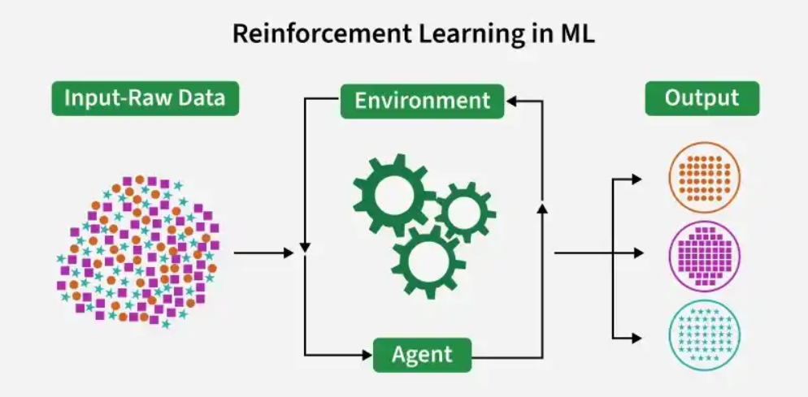
Reinforcement Learning revolves around the idea that an agent (the learner or decision-maker) interacts with an environment to achieve a goal. The agent performs actions and receives feedback to optimize its decision-making over time.
- Agent: The decision-maker that performs actions.
- Environment: The world or system in which the agent operates.
- State: The situation or condition the agent is currently in.
- Action: The possible moves or decisions the agent can make.
- Reward: The feedback or result from the environment based on the agent’s action.

Working of Reinforcement Learning
The agent interacts iteratively with its environment in a feedback loop:
- The agent observes the current state of the environment.
- It chooses and performs an action based on its policy.
- The environment responds by transitioning to a new state and providing a reward (or penalty).
- The agent updates its knowledge (policy, value function) based on the reward received and the new state.
- This cycle repeats with the agent balancing exploration (trying new actions) and exploitation (using known good actions) to maximize the cumulative reward over time.

Logistic Regression in Machine Learning
Logistic Regression is a supervised machine learning algorithm used for classification problems. Unlike linear regression, which predicts continuous values it predicts the probability that an input belongs to a specific class.
- It is used for binary classification where the output can be one of two possible categories such as Yes/No, True/False or 0/1.
- It uses sigmoid function to convert inputs into a probability value between 0 and 1.
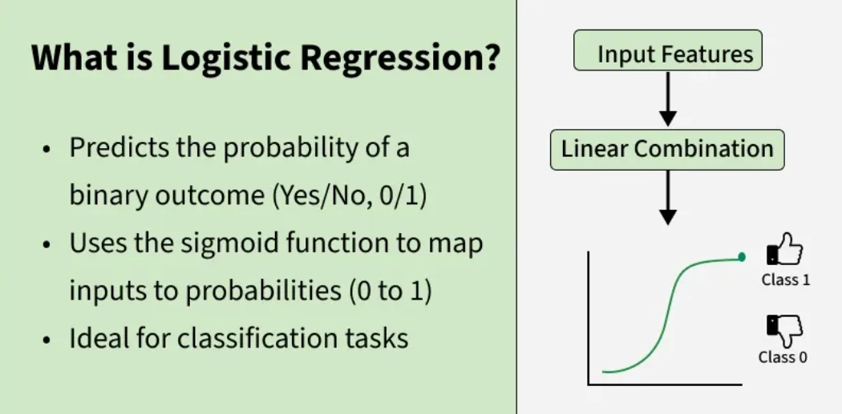
Core Idea
Logistic regression uses a linear combination of inputs, but passes it through a special function called the sigmoid (logistic) function:
$$P(y=1∣x)=\frac{1}{1+e^{-(w_{0}+w_{1}x_{1}+w_{2}x_{2}+⋯+w_{n}x_{n})}}$$
How It Works
- Compute a linear combination of input features
- Apply the sigmoid function to squash the result into [0, 1]
- Use a threshold (e.g., 0.5) to assign a class label
Example
Imagine predicting whether an email is spam:
- Input features:
  - Number of suspicious words
  - Email length
  - Sender reputation
Logistic regression outputs something like:
- 0.92 → Spam
- 0.12 → Not spam
Logistic regression is widely used in:
- Medical diagnosis
- Credit scoring
- Marketing response prediction
- Fraud detection

Linear Regression in Machine Learning
Linear Regression is a fundamental supervised learning algorithm used to model the relationship between a dependent variable and one or more independent variables. It predicts continuous values by fitting a straight line that best represents the data.
- It assumes that there is a linear relationship between the input and output
- Uses a best-fit line to make predictions
- Commonly used in forecasting, trend analysis, and predictive modelling
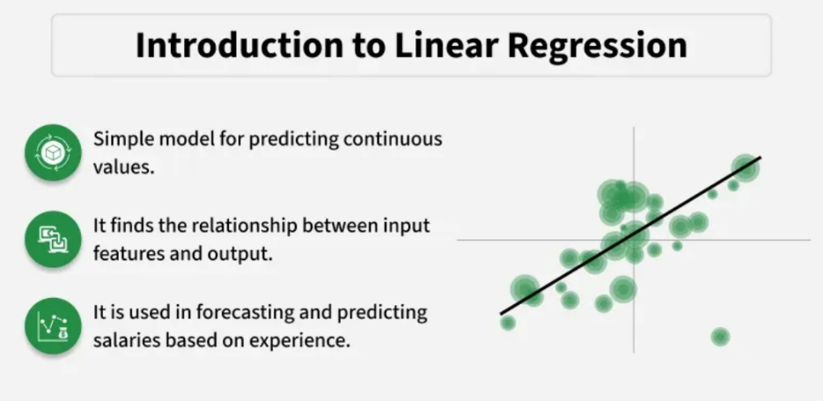
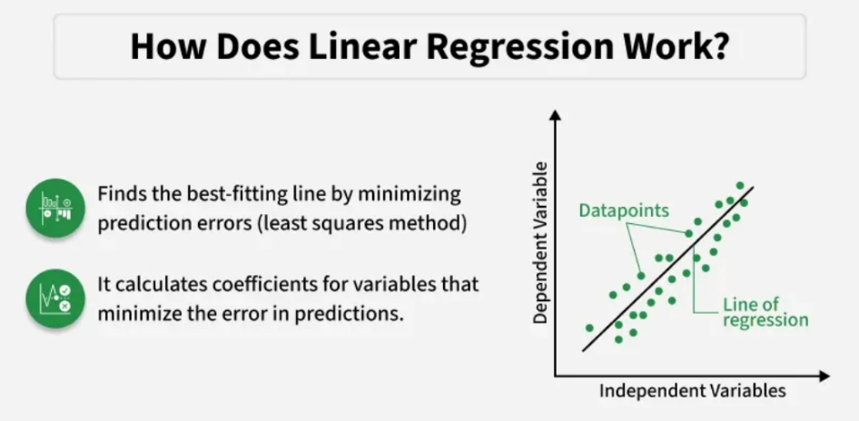
For example, we want to predict a student's exam score based on how many hours they studied. We observe that as students study more hours, their scores go up. In the example of predicting exam scores based on hours studied. Here
- Independent variable (input): Hours studied because it's the factor we control or observe.
- Dependent variable (output): Exam score because it depends on how many hours were studied.
We use the independent variable to predict the dependent variable.
Limitations
- Only captures linear relationships
- Sensitive to outliers
- Assumes features are independent
- Can underperform on complex data

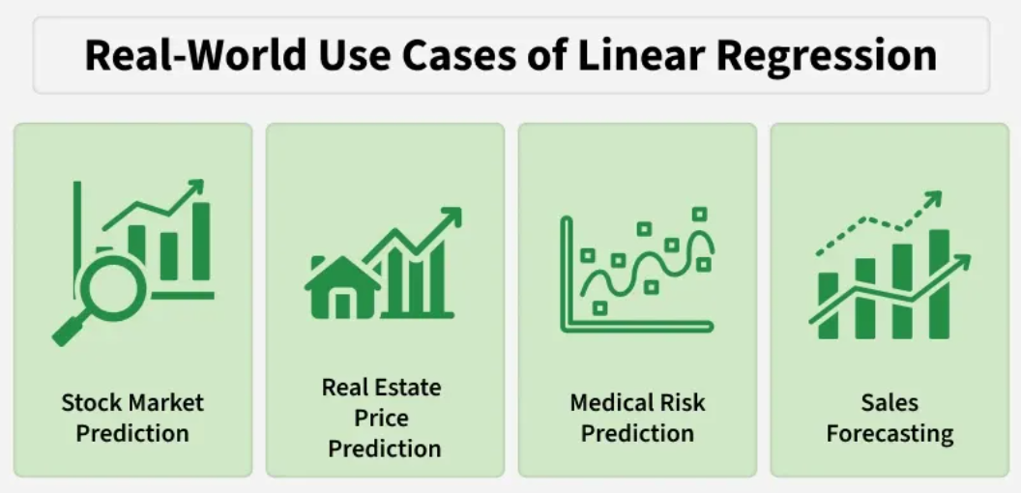

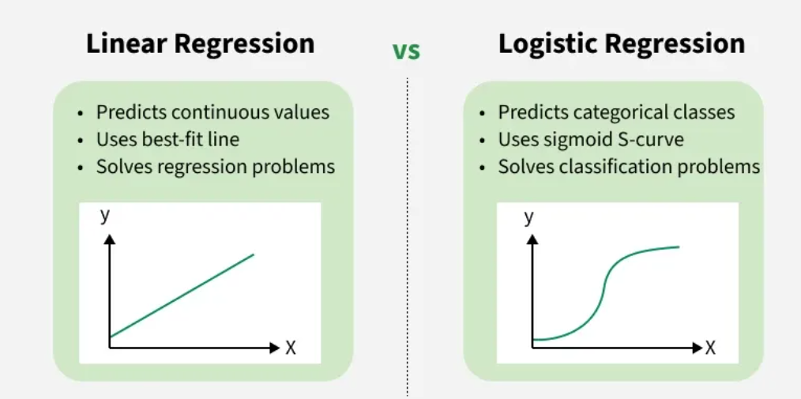
Ensemble Learning
Ensemble learning is a method where multiple models are combined instead of using just one. Even if individual models are weak, combining their results gives more accurate and reliable predictions.
- Uses multiple models together to improve overall accuracy.
- Reduces errors by balancing mistakes across models.
- Works on a simple idea similar to combining opinions from a group.
Types of Ensemble Learning:
Two of the main types of Ensemble Learning are:
- Bagging (Bootstrap Aggregating): Models are trained independently on different random subsets of the training data. Their results are then combined—usually by averaging (for regression) or voting (for classification). This helps reduce variance and prevents overfitting.
- Boosting: Models are trained one after another. Each new model focuses on fixing the errors made by the previous ones. The final prediction is a weighted combination of all models, which helps reduce bias and improve accuracy.

